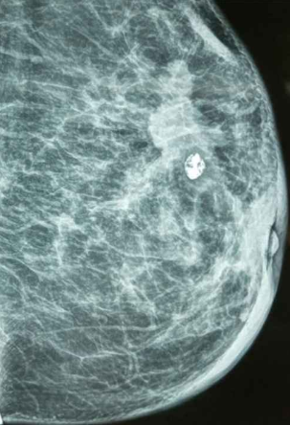

### ****Female breast cancer Stage 1****

### ****Image 1:****

**Visible Mass with Marker:**  
A radiodense (bright white) round object is present — this is likely a **biopsy marker clip**, often left behind after a **biopsy** to mark the site of an abnormality.

**Irregular Density Area:**  
Near the marker, there's a region of **increased density** which may represent a **mass** or **architectural distortion**. This warrants close follow-up or further evaluation, especially given the presence of the clip.

**Suspicious for Malignancy:**  
The combination of an irregular mass and a biopsy clip suggests the area has been previously evaluated for potential **cancer**.

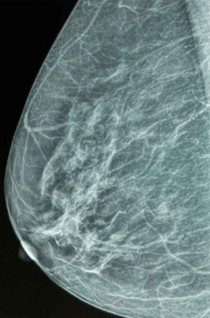

### ****Image 2:****

**No Obvious Clip or Mass:**  
This mammogram appears more homogeneous. However, there is a region of **asymmetry** or **dense fibroglandular tissue**.

**May Be Normal or Benign:**  
While no clip is seen, some **fibrous streaking** and **dense tissue** is visible, which could be part of normal variation or benign changes like **fibrocystic changes**.

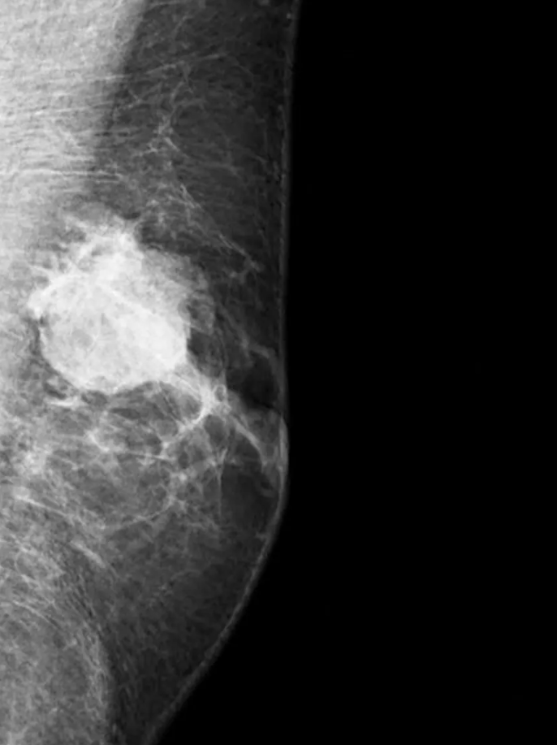

**Male breast cancer**

**Irregular Shape:**  
The lesion is **irregular**, **spiculated**, and **non-circumscribed** — all features highly suspicious for **malignancy**.

**High Density:**  
The mass appears **very radiodense (white)** compared to surrounding tissue, which is typical for **invasive breast cancer**, such as:

**Invasive ductal carcinoma (IDC)** (most common type)

Less commonly: invasive lobular carcinoma

**Architectural Distortion:**  
There's disruption of the normal tissue planes, which often accompanies **infiltrative cancers**.

